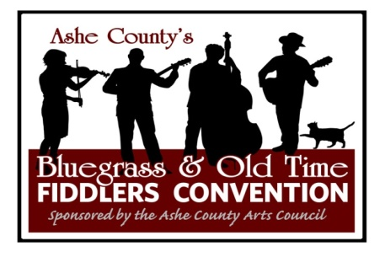 | 52nd ANNUAL  ASHE COUNTY BLUEGRASS AND OLD TIME FIDDLERS CONVENTION  July 28-29, 2023  2023 SPONSORSHIP LEVELS
Awards Sponsor - $2000
- Full page ad in program tabloid with 20,000 printed & distributed regionally & at Convention
- Name and logo and sponsor level on:
- Event website, emails, e-blasts, posters
- Link from our website to your website/Facebook
- Highlighted on Social Media
- Sponsor Tent
- 4 complimentary tickets for Saturday
- 4 complimentary tickets for concert Friday night
- Banner on Main Stage on Friday & Saturday
Saturday Stage Sponsor - $1000
- Full page ad in program tabloid with 20,000 printed & distributed regionally & at Convention
- Name and logo and sponsor level on:
- Event website, emails, e-blasts, posters
- Link from our website to your website/Facebook
- Highlighted on Social Media
- Sponsor Tent
- 4 complimentary tickets for Saturday
- 2 complimentary tickets for concert Friday night
- Banner on Main Stage on Saturday
Friday Night Stage Sponsor - $750
- Full page ad in program tabloid with 20,000 printed & distributed regionally & at Convention
- Name and logo and sponsor level on:
- Event website, emails, e-blasts, posters
- Link from our website to your website/Facebook
- Highlighted on Social Media
- 4 complimentary tickets for concert Friday night
- 2 complimentary tickets for Saturday
- Banner on Main Stage Friday night

Platinum Sponsor - $500
- Half-page ad in program tabloid with 20,000 printed & distributed regionally & at Convention
- Name and logo and sponsor level on:
- Event website, emails, e-blasts, posters
- Link from our website to your website/Facebook
- Highlighted on Social Media as Sponsor
- 2 complimentary tickets for concert Friday night
- 2 complimentary tickets for Saturday
Gold Sponsor - $300
- One-third page ad in program tabloid with 20,000 printed & distributed regionally & at Convention
- Name and logo and sponsor level on:
- Event website, emails, e-blasts
- Poster
- Link from our website to your website/Facebook
- Highlighted on Social Media as Sponsor
- 2 complimentary tickets for Saturday
Silver Sponsor - $150
- Quarter-page ad in program tabloid with 20,000 printed & distributed regionally & at Convention
- Name and logo and sponsor level on:
- Event website, emails, e-blasts
- Highlighted on Social Media as Sponsor
- 2 complimentary tickets for Saturday

Bronze Sponsor - $75
- One-eighth page ad in program tabloid with 20,000 printed & distributed regionally & at Convention
- Highlighted on Social Media as Sponsor
- 1 complimentary ticket to for Saturday

